Chapter 9, Solution 11.

(a) 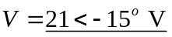

(b)
I = 8∠160° mA
(c )
V = 120∠–140° V
(d)
I = 60∠–170° mA

